**EE387 – SIGNAL PROCESSING**

**LAB 2**

GUNARATHNE K.G.G.C.B

E/14/108

SEMESTER 6

12/11/2018

**Discrete Time Signals**

1) Understanding properties of Discrete Time Sinusoidal signals

a.

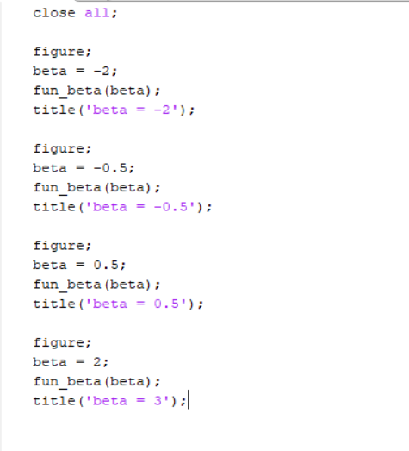

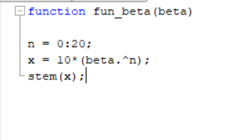

1. 𝛽 < −1

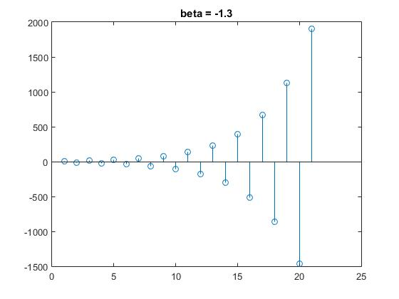

ii. −1 < 𝛽 < 0

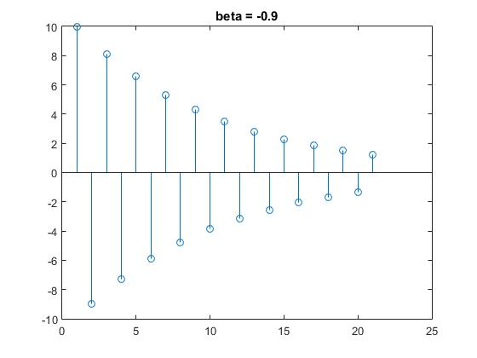

iii. 0 < 𝛽 < 1

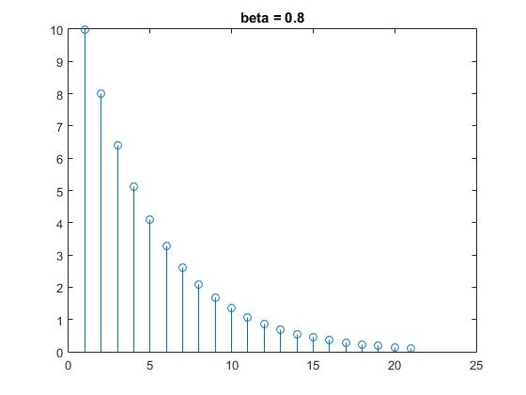

iv. 𝛽 > 1

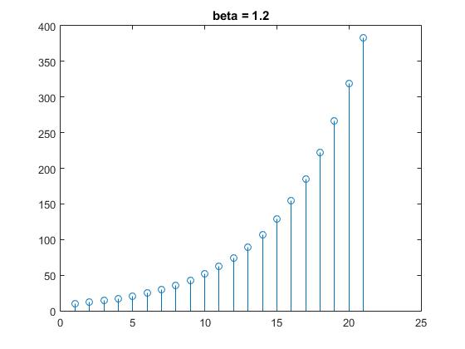

b.

code

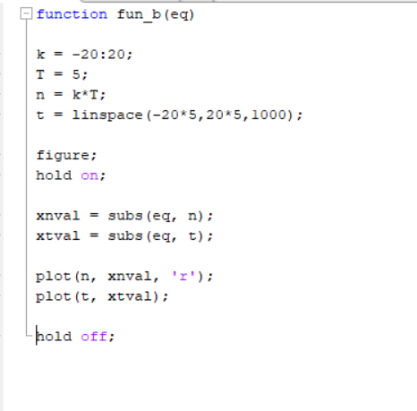

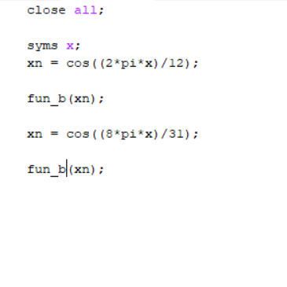

Output

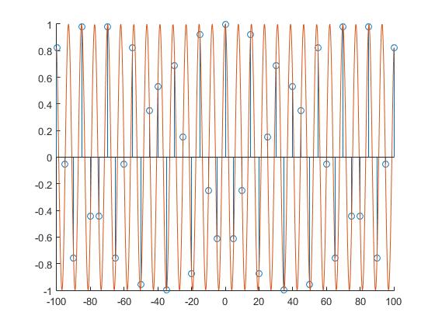

X[n] = cos((8*pi*x)/31)

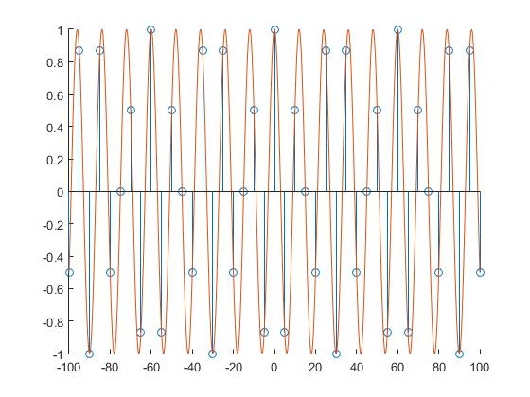

X[n] = cos((2*pi*x)/12

c.

code

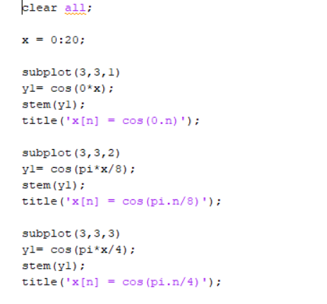

Output

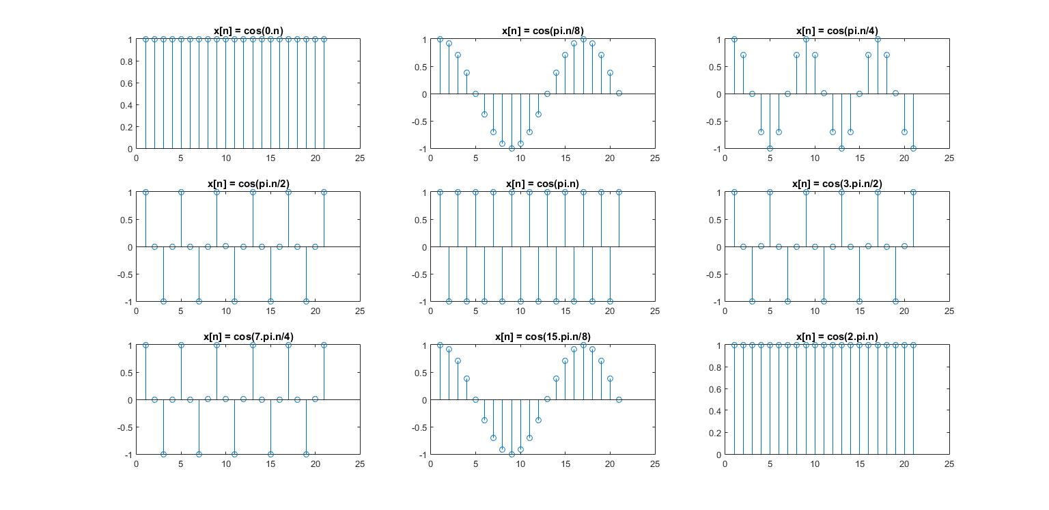

d. By observing the plots we can identify that the pattern will repeat at 2*pi cycles.

**Discrete convolution**

a.

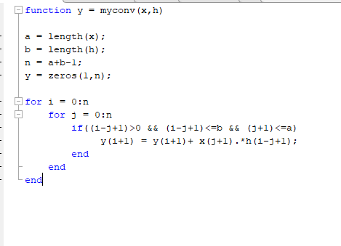

b.

code

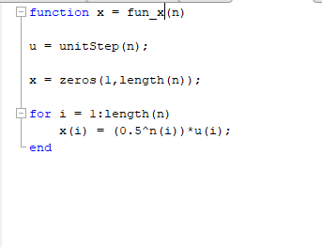

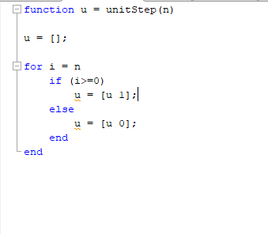

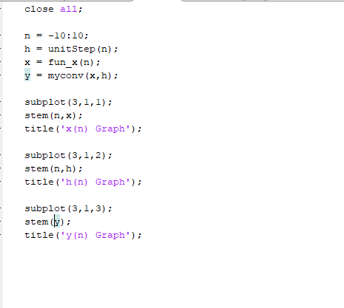

Output

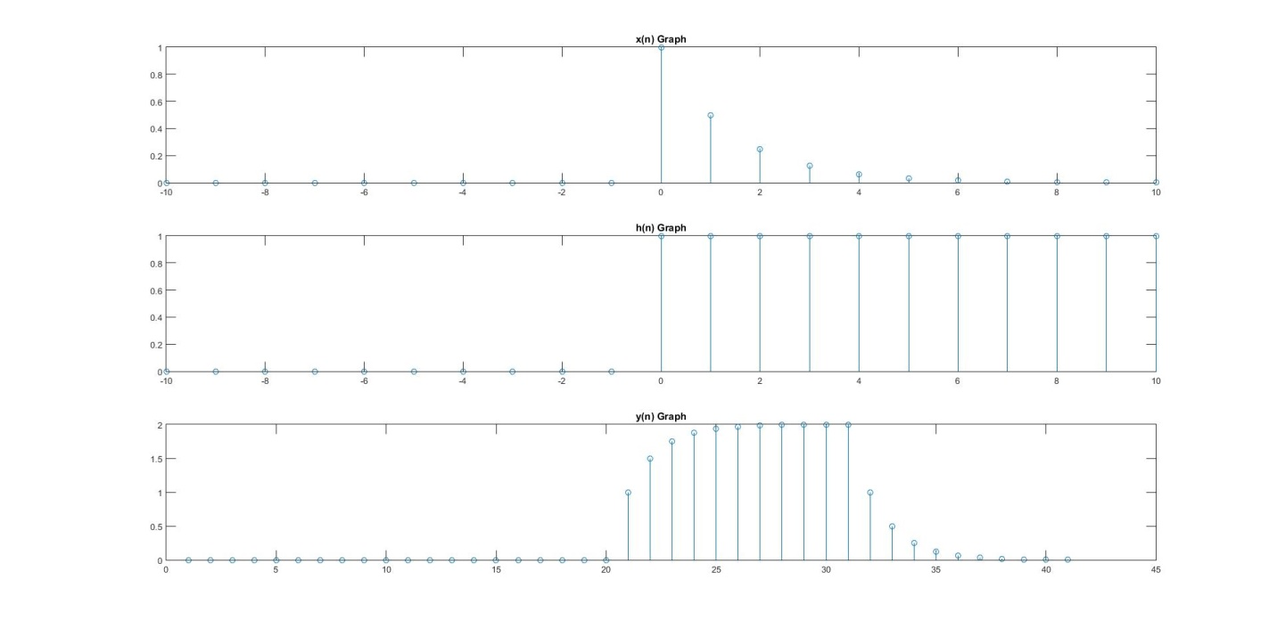

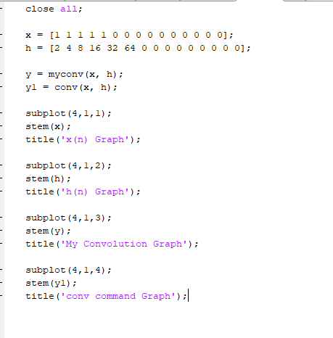c.

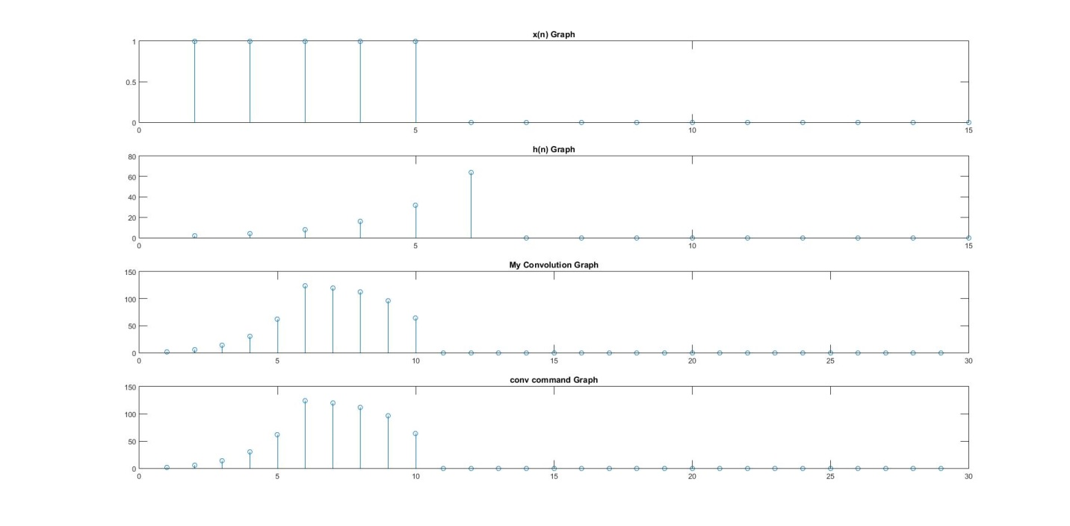Output

**LTI Systems**

a.

**i)**

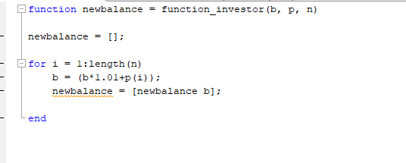

ii)

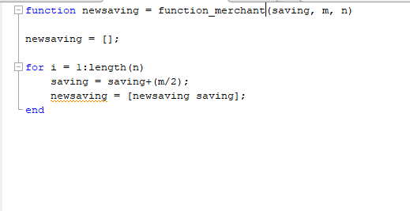

b.

code

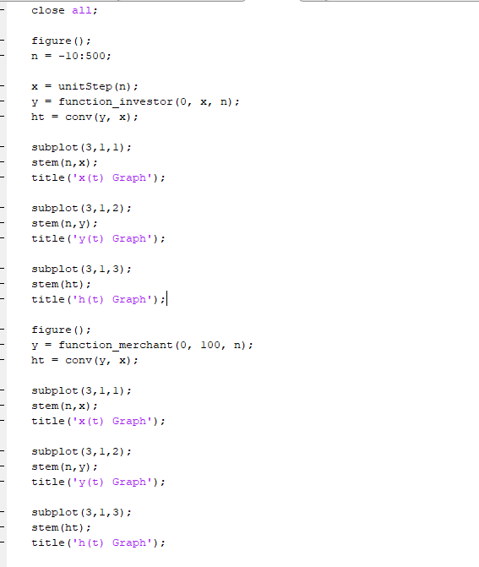

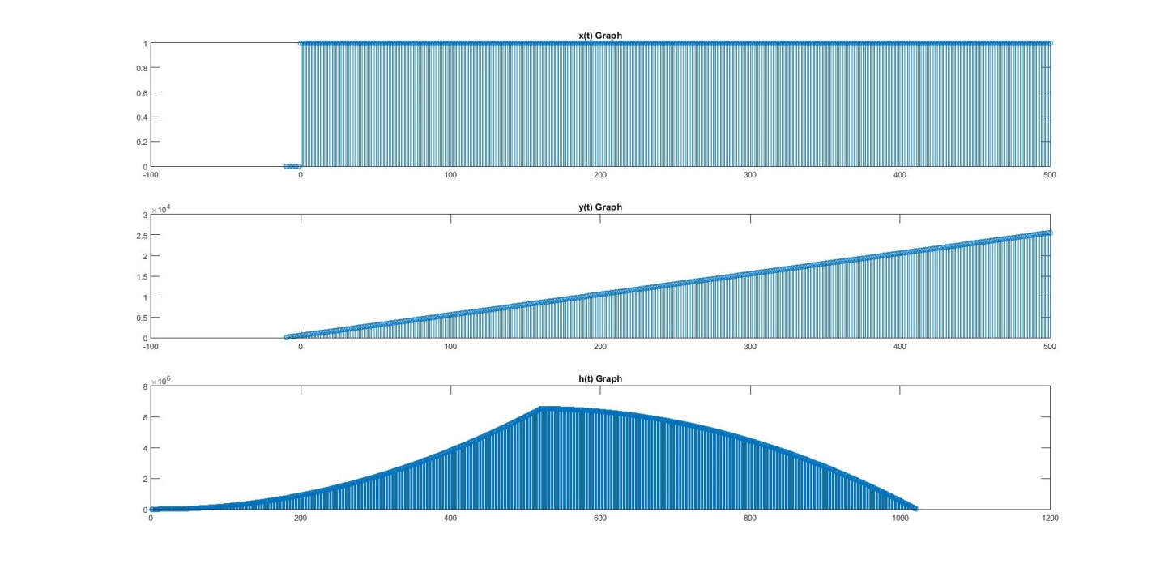Output

Merchant Function Impulse Response

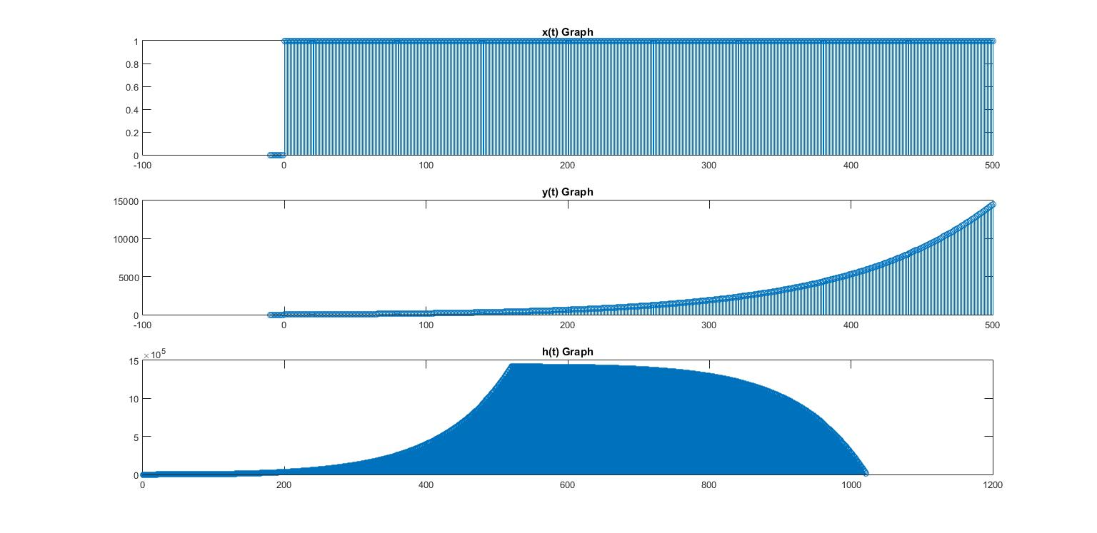

Investor Function Impulse Response

c. we can see that investor bank account function is an IIR system. This is because the function depends on both previous outputs and previous inputs. But in the merchant function only the input matters. So it is a FIR system. It is clearly shown in the graphs. In IIR system the graph grow exponentially while merchant function has a constant increment.